ANVIQ Website
Design & code changes: before and after
Project folder: arogya-ai • Final version for team review • 28 September 2026

Summary
This document shows every part of the ANVIQ website that was changed, what it looked like before, and what it looks like now. The page layout and all text content stay the same, except where noted.
Area | Before | After
Colours | Navy blue + orange, with purple and blue accents | Deep teal green + orange, with mint highlights
Style | Flat white cards | Glassmorphism: frosted glass cards with a mirror shine on hover
Navbar | Full-width white bar, underline on active link | Floating rounded glass bar, pill links, "Start Free Trial" button
Hero | White strip above navbar | Hero background runs to the top of the page
Faster Prescriptions cards | 4 cards in one row, uneven text and gaps | 2 cards per row, text and tags aligned
Section backgrounds | Plain white / light blue-grey | Plain white / soft grey (no colour glow)
Plans page | White cards on white background | Full-width dark teal glass panel, round check icons
Resources page | Rocket image, "Launching soon" text | Teal hero with animations, working "Notify me" form, content cards, product links
Plan comparison table | Header covered the first row, empty gap on top, harsh dark hover | Header fixed, all rows visible, soft hover
Forms | Early access form only showed a message; nothing was sent | Real backend: every form emails vikash@lumeneo.ai and thanks the visitor
Code | Unused CSS, duplicate rules, 10 inline <style> blocks | Cleaned CSS, split into clear files
Note: the screenshots were taken in a test browser without the Mulish font, so the font looks slightly different from the live site. Colours and layout are accurate.

1. Colour palette
The main colour changed from navy blue to deep teal green. The orange from the logo is kept for buttons. Purple and blue accents were removed so the site uses fewer colours.
Role | Before | After | Used for
Primary | ███ #122056 | ███ #0A3D3A | Hero, headings, dark sections
Primary hover | ███ #1E2B6A | ███ #12574F | Gradients, hover states
Buttons | ███ #F2572B | ███ #F2572B | Start Free Trial, CTA buttons (unchanged)
Highlight | ███ #5B65DD | ███ #2DD4BF | "Clinical Care" text, badges, ticks
Light background | ███ #F7F8FD | ███ #F5F7F8 | Alternate light sections
Body text | ███ #4A5578 | ███ #4B5F63 | Paragraph text

2. Page-by-page changes

2.1 Navbar
BEFORE
- Full-width white bar fixed to the top.
- Active page shown with an orange underline.
- No call-to-action button.
AFTER
- Floating, rounded glass bar with a soft shadow.
- Each link is a pill; the active page is a dark teal pill.
- New "Start Free Trial" button with a round orange arrow (opens the signup page). Hidden on screens under 1100px.

2.2 Home hero
BEFORE
- Navy background with blue/purple glow.
- "Clinical Care" in a purple-to-teal gradient.
- Thin white strip above the navbar.
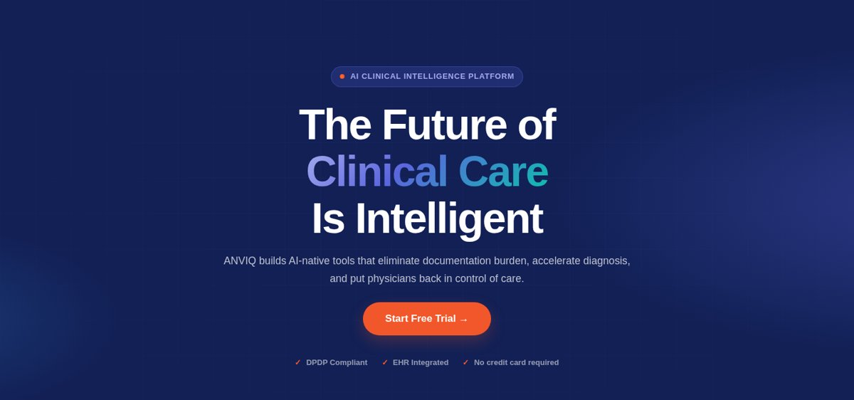
AFTER
- Deep teal background with soft mint and orange glow.
- "Clinical Care" in a mint gradient; eyebrow tag in mint.
- Background starts at the very top, behind the floating navbar.
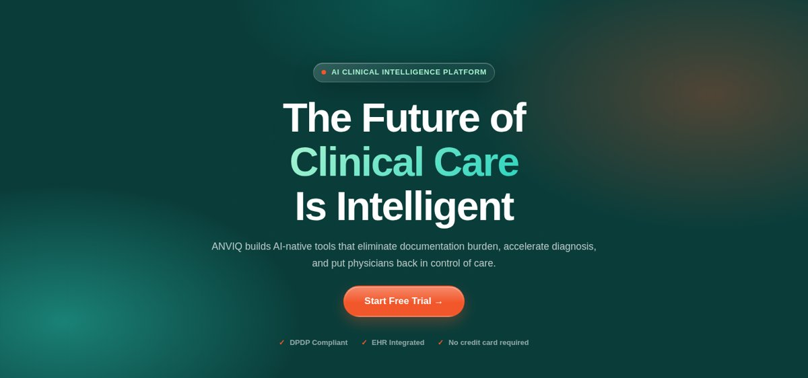

2.3 "Faster Prescriptions. Safer Patients." cards
BEFORE
- 4 narrow cards in one row.
- First card had much more text, so the others had large empty gaps.
- Tags sat at different heights.
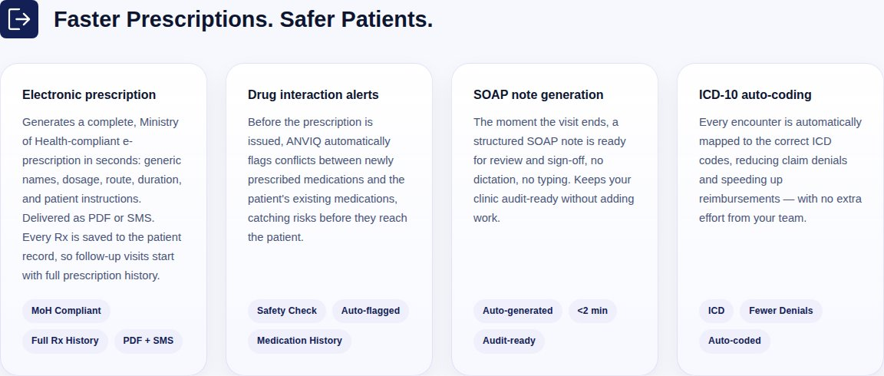
AFTER
- 2 cards per row (1 per row on mobile), no icons.
- Title, text and tags line up across cards; a thin line separates the tags.
- Shorter text on the first two cards so all cards are similar in length.
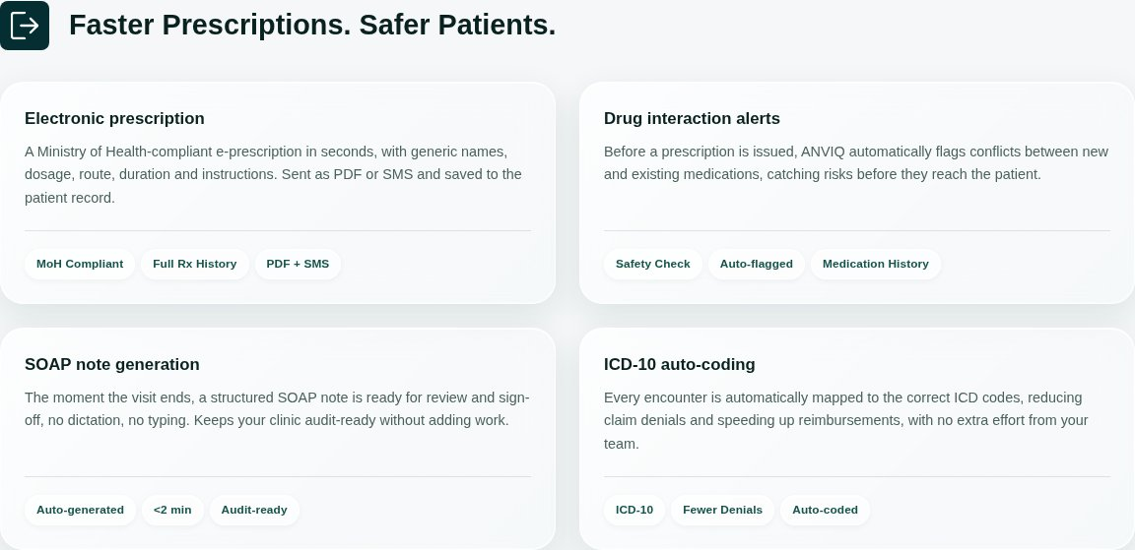

2.4 Product cards
BEFORE
- Plain white cards with a thin border.
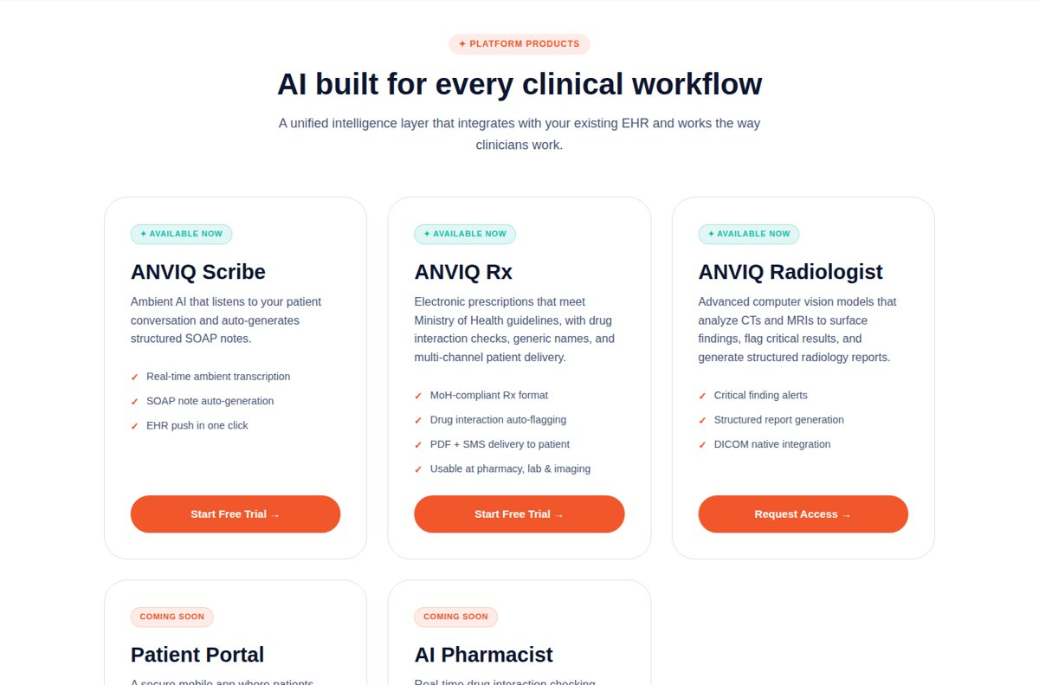
AFTER
- Frosted glass cards with a light edge highlight.
- On hover a mirror-like shine moves across the card.
- Glossy orange buttons.
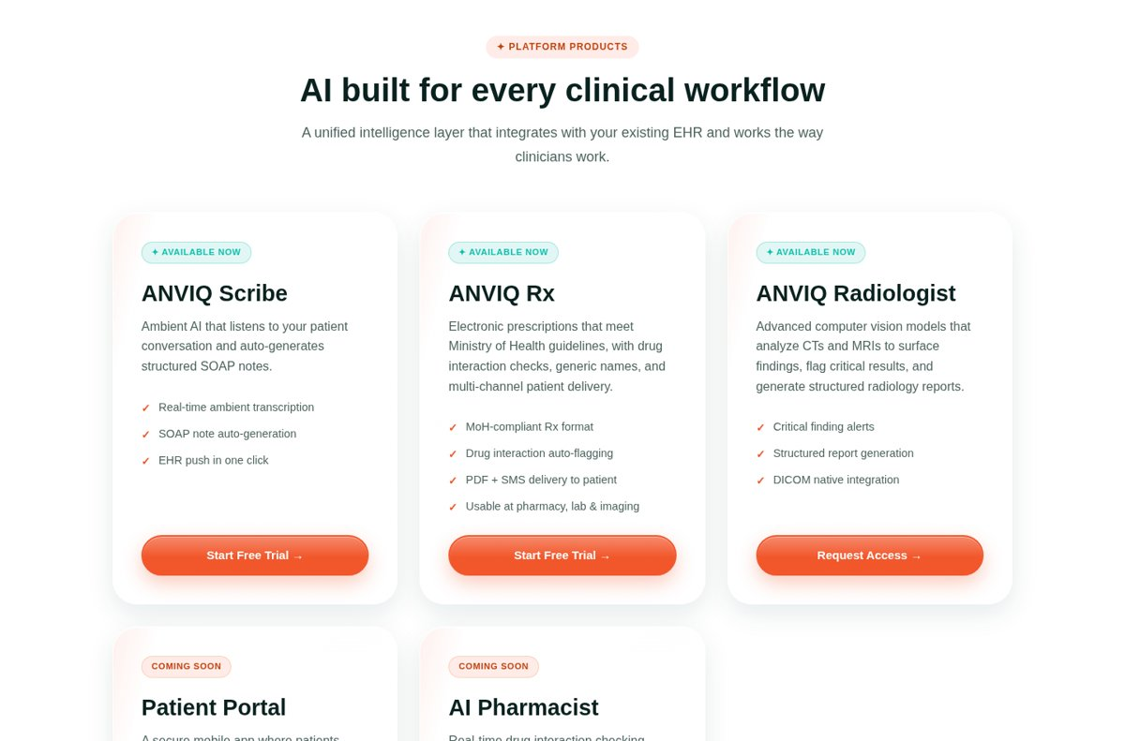

2.5 Trust section ("Trusted. Compliant. Proven.")
BEFORE
- Navy background with flat stat boxes.
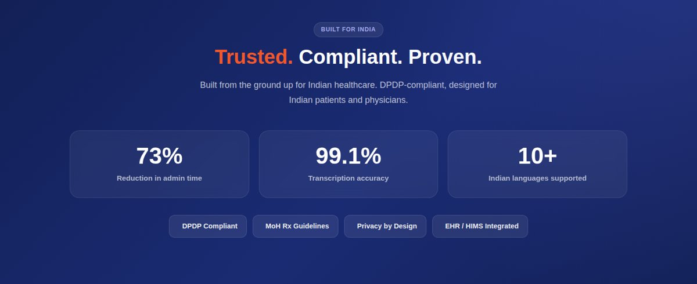
AFTER
- Teal background; stat boxes and badges are dark glass with a light edge.
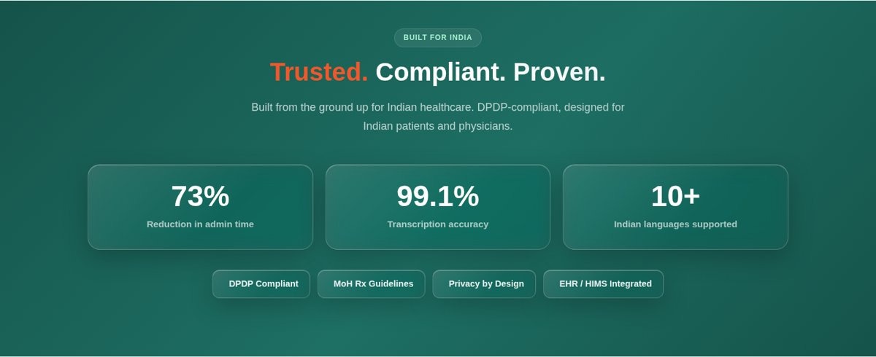

2.6 Plans page
BEFORE
- Navy hero, then white cards on a white background.
- Features listed with plain ✔ text.
- Buttons at the top of each card.
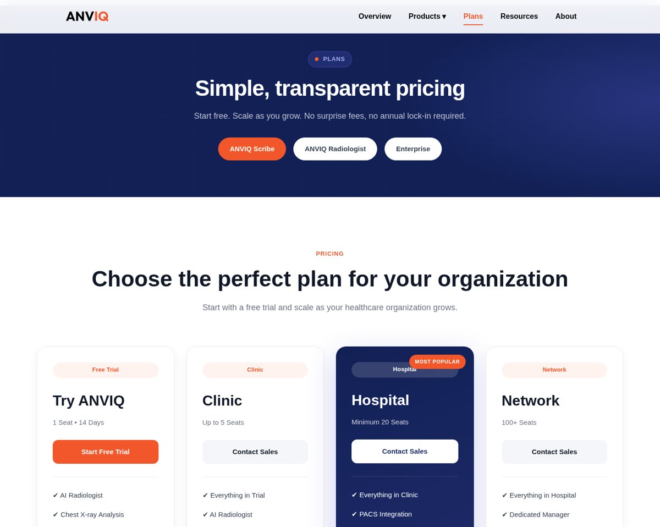
AFTER
- The pricing area is a full-width dark teal glass panel joined to the hero.
- Glass cards with white pill tags and round mint check icons.
- Buttons moved to the bottom; the Hospital card is highlighted with a mint button.
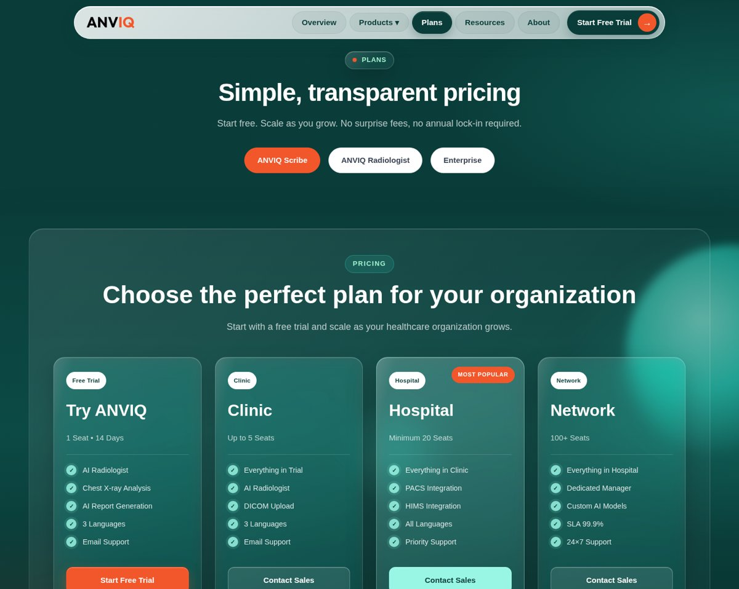

2.7 Resources page
BEFORE
- White page with a purple rocket image.
- "Resources Hub" title, four text pills and a Back to Home button.
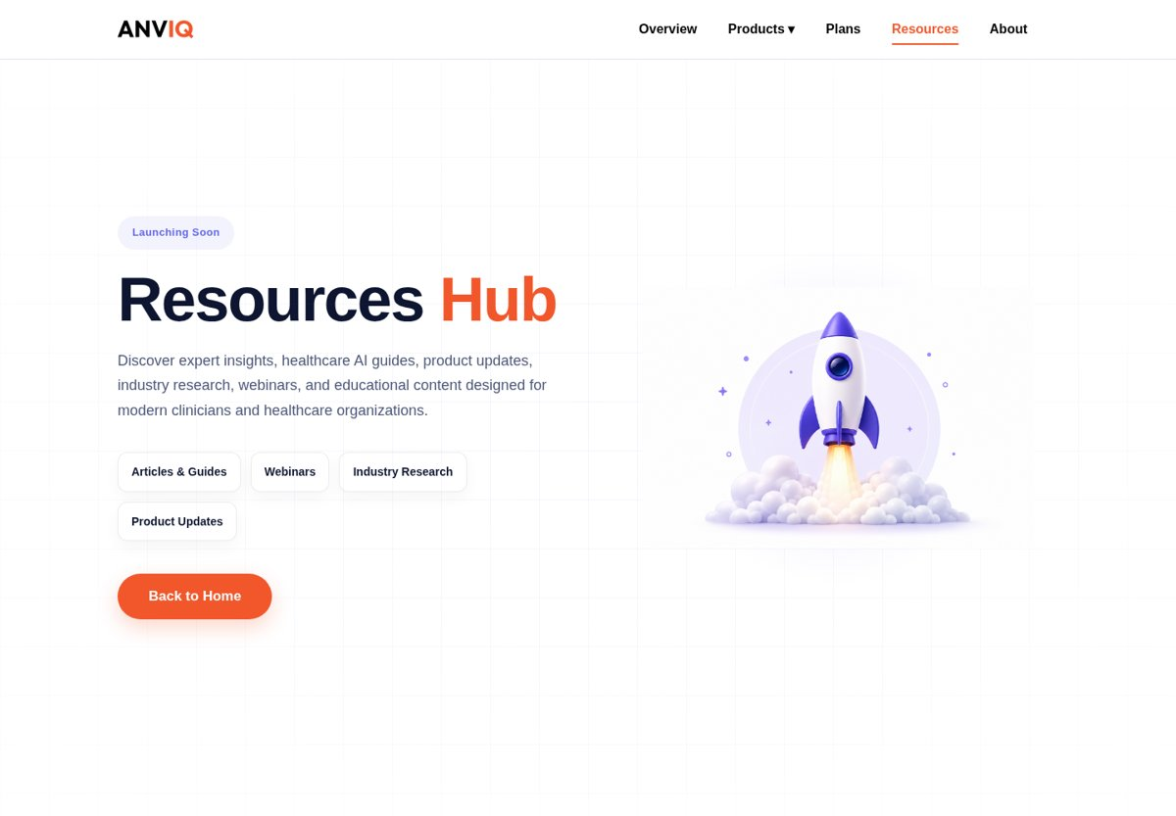
AFTER
- Teal hero: "Learn faster with ANVIQ Resources" and a "Notify me" email form.
- Floating glass preview cards (Guide, Webinar, Research).
- New sections: "What's coming" (4 content types), "Explore the ANVIQ platform" (links to Scribe, Rx, Radiologist) and a Start Free Trial call-to-action.
- The right side is animated: cards tilt with the mouse, rings rotate, bars grow, a status pill cycles "Guides / Webinars / Research / Updates".
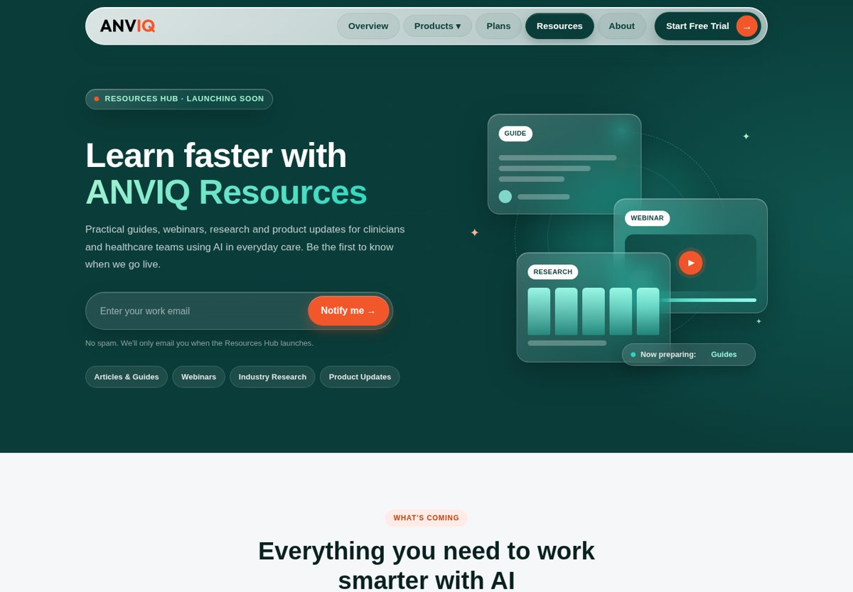
AFTER: new "What's coming" section
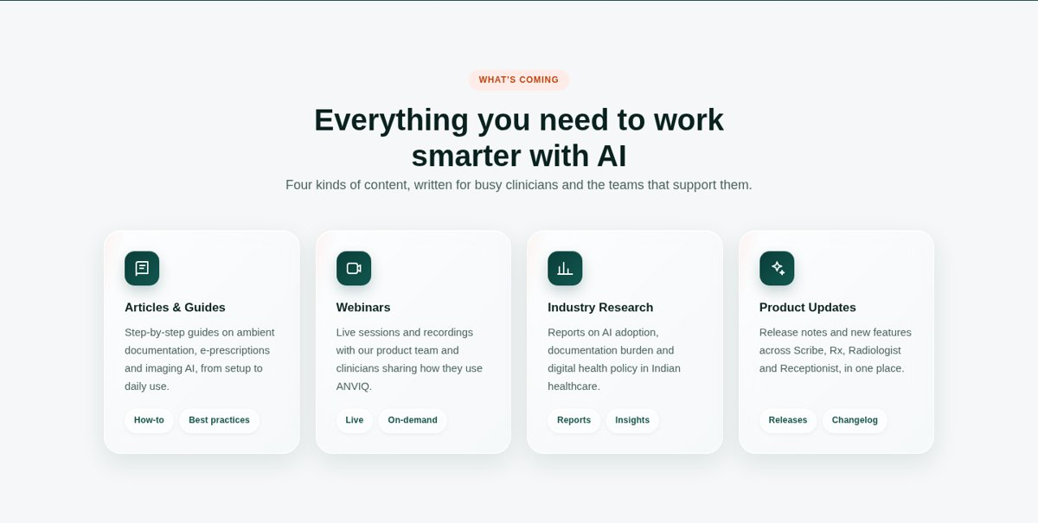
AFTER: animation (three moments of the moving hero)
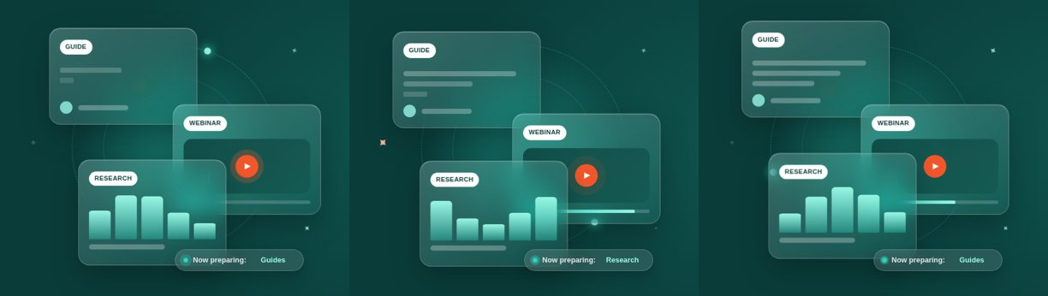

2.8 Plans page: feature comparison table
BEFORE
- The header row slid down inside the table and covered the first row (AI Chest X-ray).
- An empty white gap showed above the header.
- On hover, the Hospital cell turned solid dark teal.
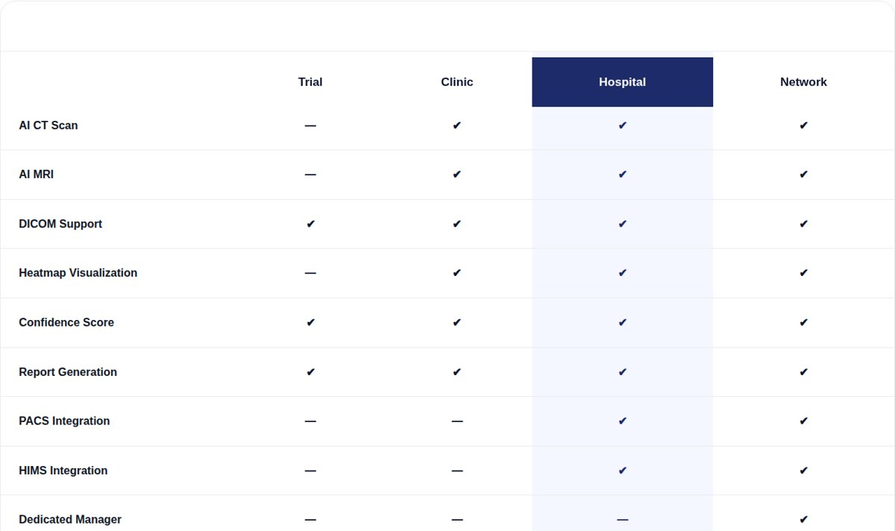
AFTER
- Header sits at the top; every row is visible.
- Soft tint on row hover; the Hospital column is highlighted in light teal.
- On mobile the feature names stay visible while scrolling sideways.
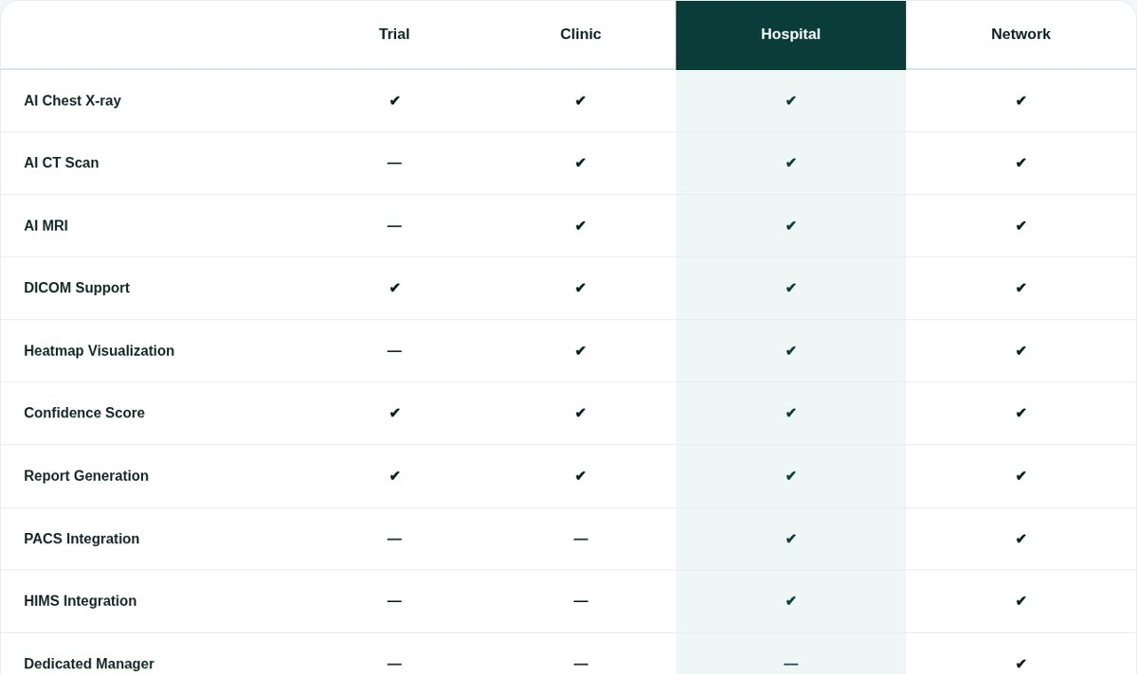

2.9 Forms and email backend
BEFORE
- "Request Early Access" popup and the Resources "Notify me" form only showed a thank-you message.
- No details were saved or emailed to anyone.
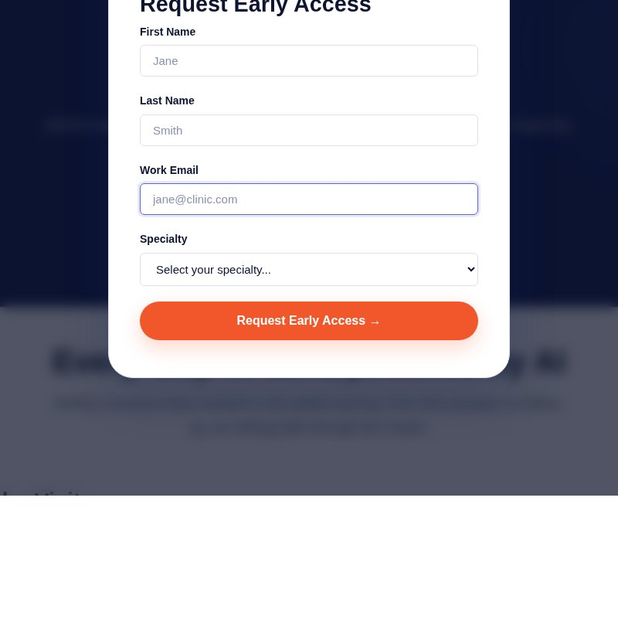
AFTER
- Both forms send the details to a backend (Node.js; runs as Vercel functions in /api).
- Each submission emails vikash@lumeneo.ai (name, email, specialty, plan) and sends the visitor a thank-you email.
- Spam protection: hidden trap field, 5 requests per 10 minutes per visitor, server-side checks.
- Needs the mailbox App Password in .env (local) or Vercel Environment Variables (live). Setup steps are in BACKEND.md.
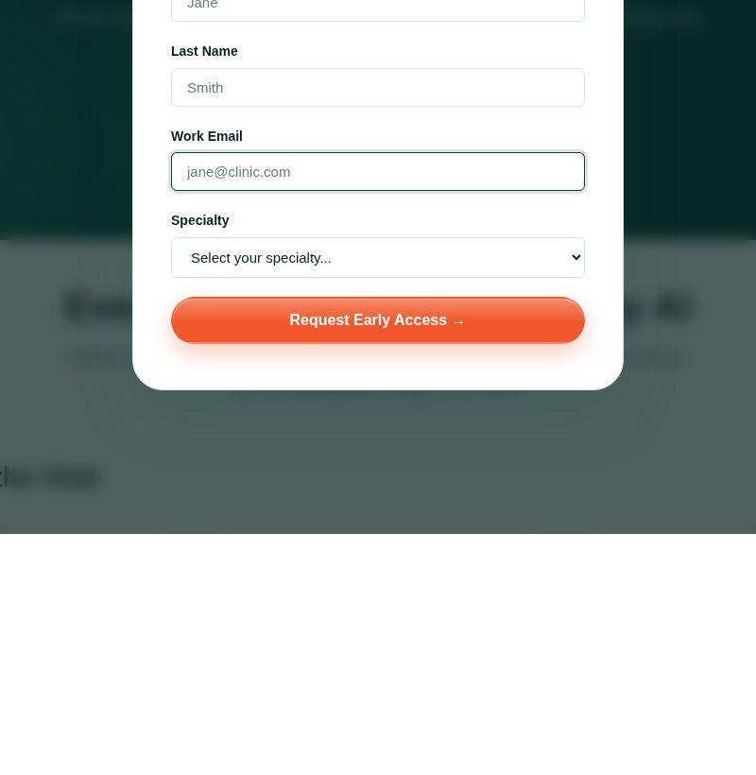

2.10 Mobile view
The same changes apply on phones. The navbar becomes a rounded glass bar with the menu button; cards stack one per row.
BEFORE | AFTER
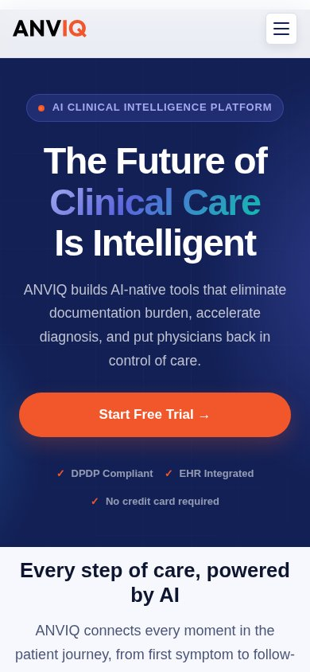 | 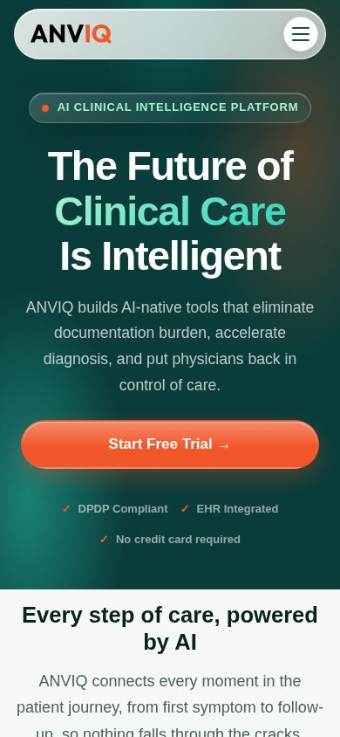

3. Code cleanup
Change | Result
Unused CSS removed | 184 selectors that matched nothing on the site, plus unused colour variables and animations
Dead CSS removed | 205 properties that were always overridden by a later rule
Inline styles moved | 10 <style> blocks moved out of index.html into css/pages.css (index.html went from about 5,760 to 3,500 lines)
Old Resources CSS removed | Styles for the old rocket layout, no longer used
JavaScript | Removed a duplicate loop in navigation.js; forms now send to the backend; hero animation script
Backend | New email backend for both forms (server.js for local, api/ for Vercel)
Checks | No CSS syntax errors; no JavaScript errors; every page checked on desktop and mobile

Files
File | What it contains
css/variables.css | Colour tokens (teal, orange, mint, greys)
css/main.css, css/sections.css | Base styles, cleaned up
css/pages.css | Styles moved out of index.html
css/glass.css (new) | Glass / mirror effect on cards, buttons and dark sections
css/pricing-glass.css (new) | Plans page glass panel
css/nav-glass.css (new) | Floating navbar
css/resources.css (new) | New Resources page
server.js, api/, lib/mailer.js (new) | Form backend and email templates
.env.example, BACKEND.md (new) | Email settings template and setup guide
CHANGES.md | Change log and revert steps

How to undo a change
- Remove one design: delete its <link> line in index.html (glass.css, pricing-glass.css, nav-glass.css or resources.css).
- Old navy look (after cleanup, before teal + glass): copy the files from the backup-before-teal-glass folder.
- Original code before any change: copy the files from the backup-before-css-refactor folder.
- With git: commit the current state, then use git revert to undo it later.

4. Your review
Please open the website, go through each page on laptop and phone, and share your feedback. Short answers are fine. Mention the page and what you would change.
# | Question | Your answer
1 | Overall, do you like the new teal green + orange look? (Yes / No / Partly)
2 | Is any text hard to read, or any colour too strong or too light?
3 | Navbar: is the floating bar and "Start Free Trial" button clear and easy to use?
4 | Plans page: are the plans and the comparison table easy to understand?
5 | Resources page: are the animations nice, or too much / distracting?
6 | Did anything look broken or out of place on your phone?
7 | Anything you want changed, added or removed? (page + change)
Thank you! Reply in the group or add your answers in the table above.

